**Data Analysis**

1. Conclusions: Based on the provided date about Crowdfunding campaigns following are the three conclusions:

a. Average funding falling between $10,000 to $20,000 were more successful.

b. Projects funded during holiday season were more successful.

c. Subcategory Plays performed better than any other category.

2. Limitations of Dataset

a. Different types of Currencies used.

b. Very short time interval between launched date and End Deadline.

3. Possible Tables and/or graphs

a. We can create table based on funded and outcome to show relation between funding and projects outcome.

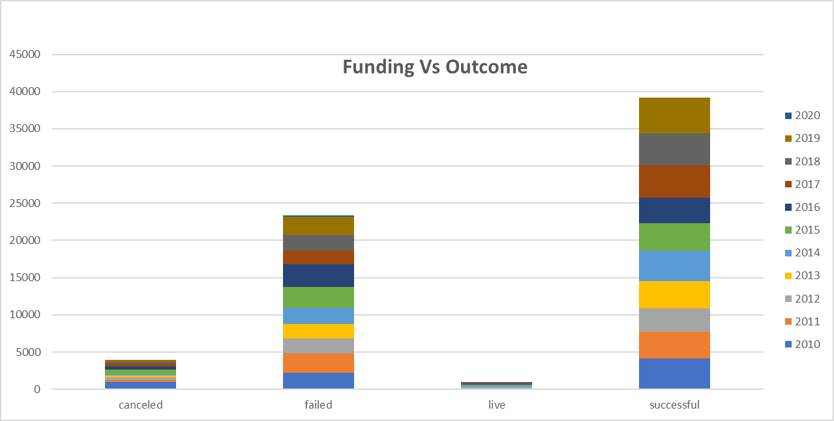



**Statistical Analysis**

